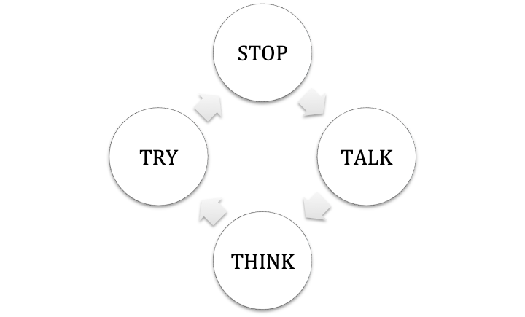

Draw Sarah and Jin and their lemonade stand here. Don’t forget the cookies!